**ASSIGNMENT 1**

**NAME : - SUSHANT KUMAR SINGH**

**EMAIL :-** [**ssushant886@gmail.com**](mailto:ssushant886@gmail.com)

**Task:1. Database Design:**

**1. Create the database named "TechShop"**

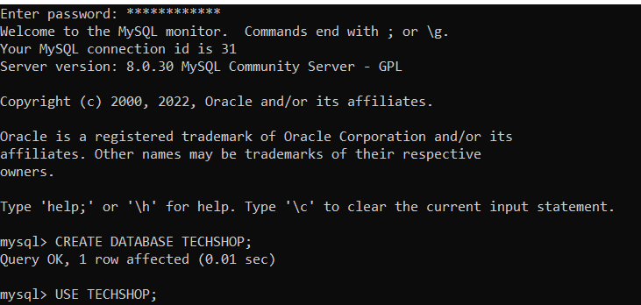

**2. Define the schema for the Customers, Products, Orders, OrderDetails and Inventory tables based on the provided schema.**

**a) Customers**

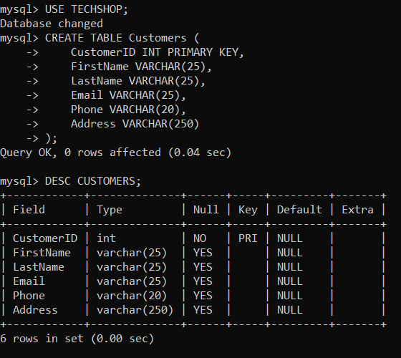

**b) PRODUCTS**

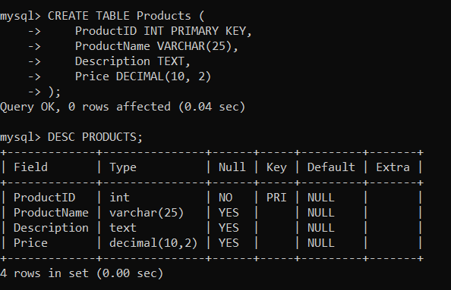

**c) ORDERS**

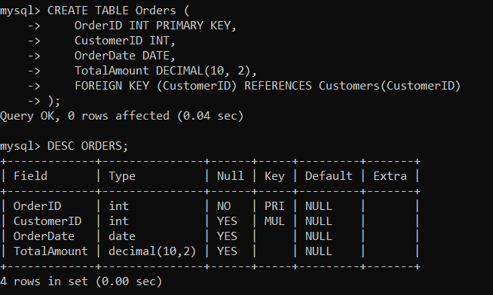

**d) ORDERDETAILS**

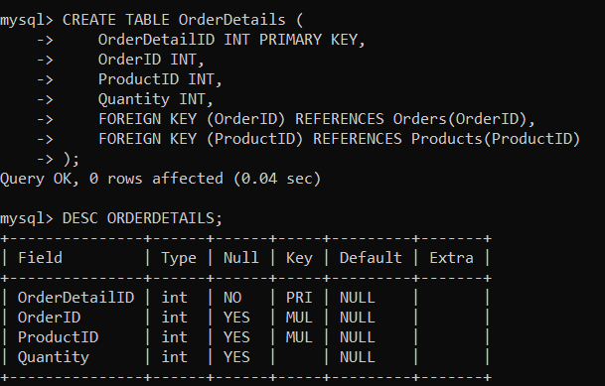

**e) INVENTORY**

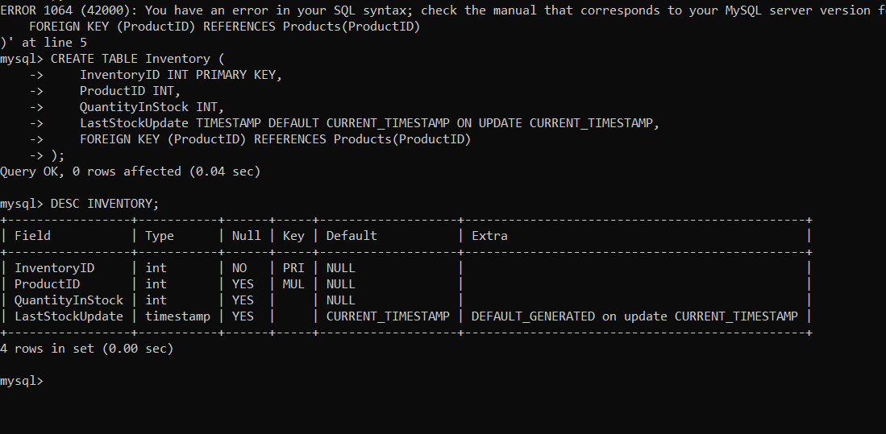

**3. Create an ERD (Entity Relationship Diagram) for the database.**

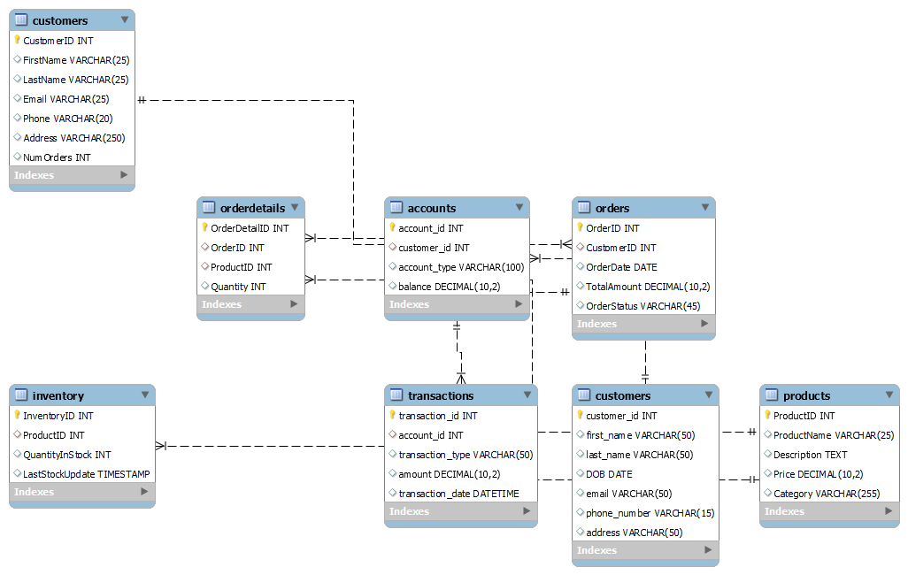

**4. Create appropriate Primary Key and Foreign Key constraints for referential integrity.**

**CREATE TABLE Orders (**

**OrderID INT PRIMARY KEY,**

**CustomerID INT,**

**OrderDate DATE,**

**TotalAmount DECIMAL(10, 2),**

**FOREIGN KEY (CustomerID) REFERENCES Customers(CustomerID)**

**);**

**5. Insert at least 10 sample records into each of the following tables. a. Customers b. Products c. Orders d. OrderDetails**

**a) Customers**

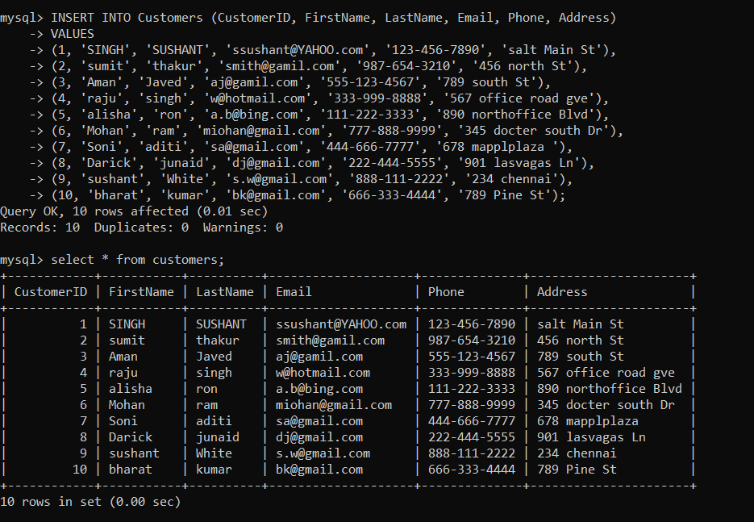

**b. Products**

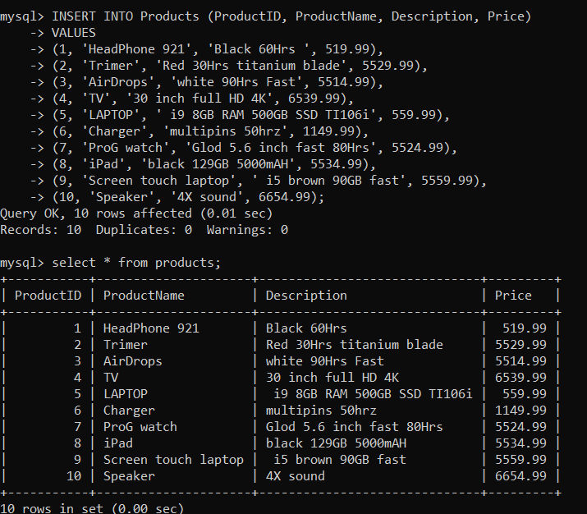

**c) Orders**

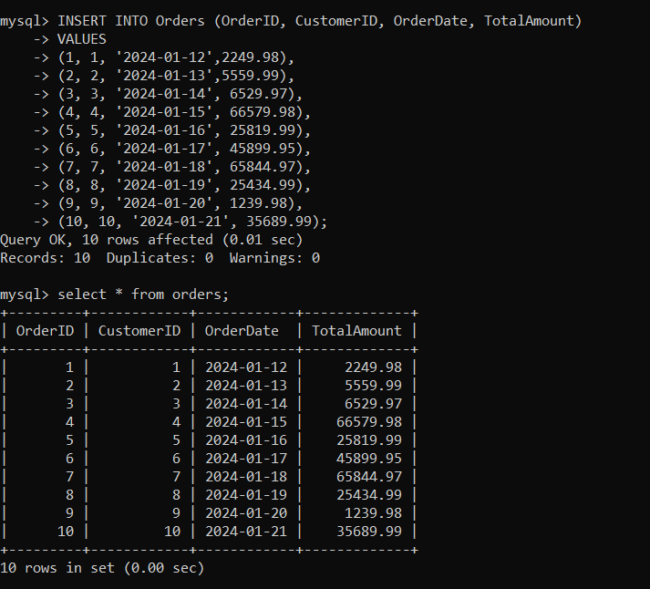

**d. OrderDetails**

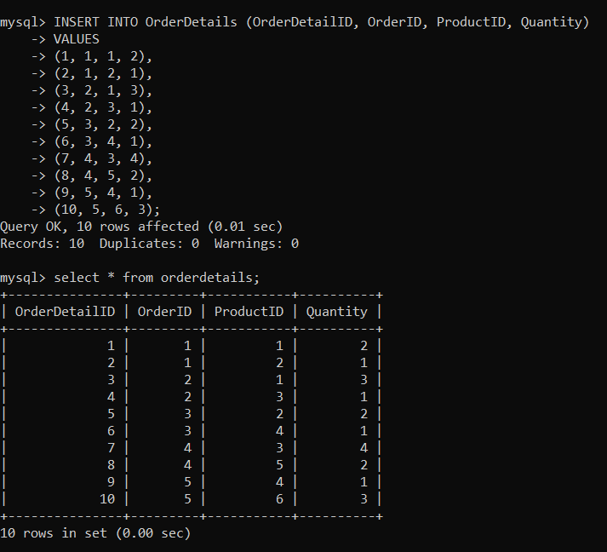

**e) INVENTORTY**

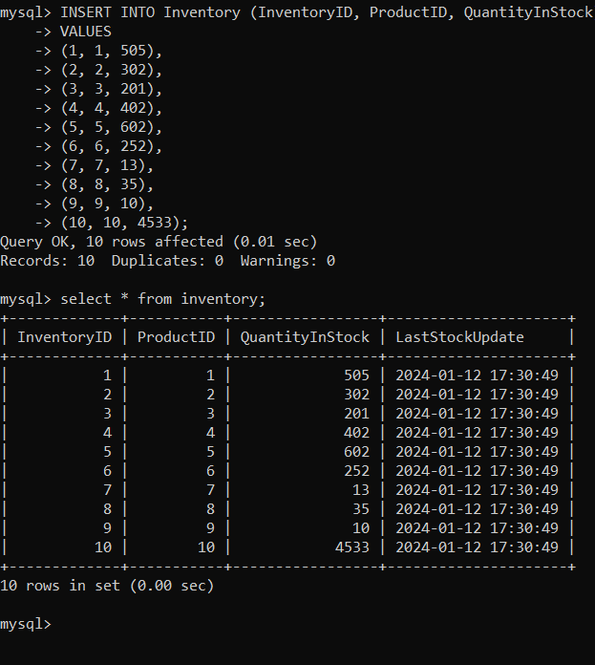

**Tasks 2: Select, Where, Between, AND, LIKE:**

**1. Write an SQL query to retrieve the names and emails of all customers.**

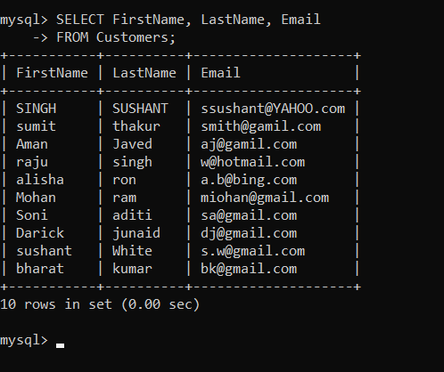

**2) Write an SQL query to list all orders with their order dates and corresponding customer names**

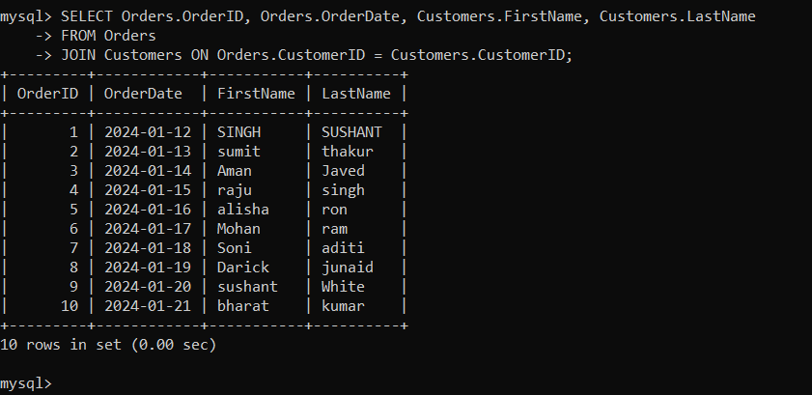

**3. Write an SQL query to insert a new customer record into the "Customers" table. Include customer information such as name, email, and address.**

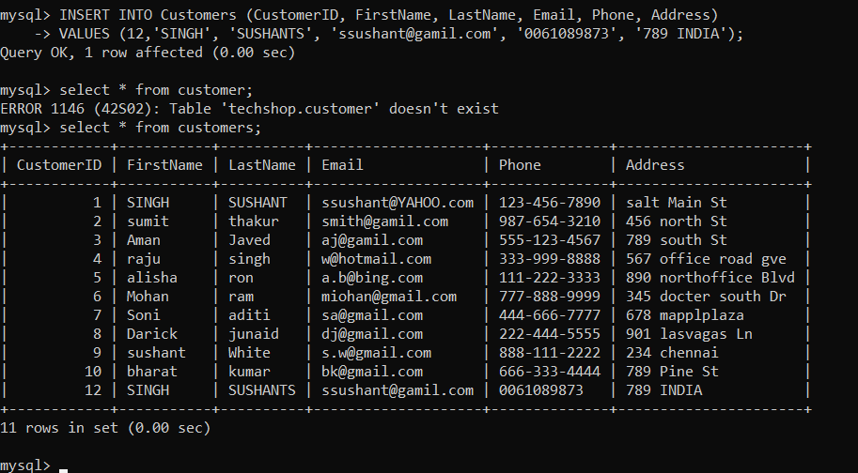

**4. Write an SQL query to update the prices of all electronic gadgets in the "Products" table by increasing them by 10%.**

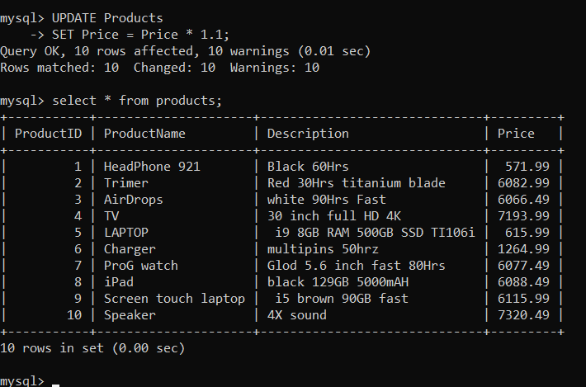

**5. Write an SQL query to delete a specific order and its associated order details from the "Orders" and "OrderDetails" tables. Allow users to input the order ID as a parameter.**

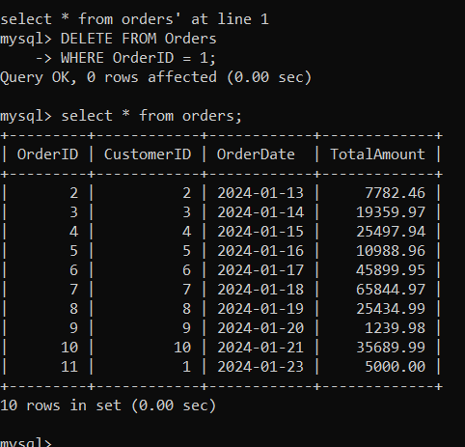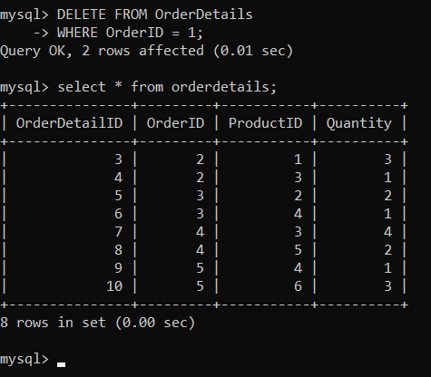

**6. Write an SQL query to insert a new order into the "Orders" table. Include the customer ID, order date, and any other necessary information.**

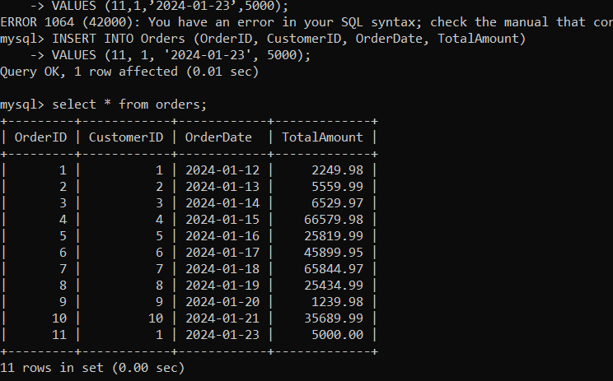

**7. Write an SQL query to update the contact information (e.g., email and address) of a specific customer in the "Customers" table. Allow users to input the customer ID and new contact information.**

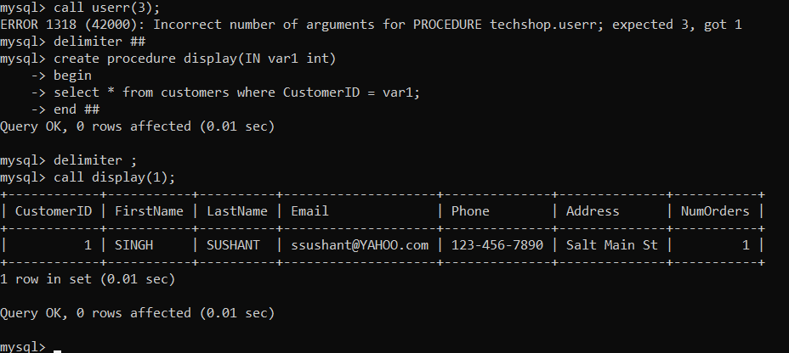

**8. Write an SQL query to recalculate and update the total cost of each order in the "Orders" table based on the prices and quantities in the "OrderDetails" table**

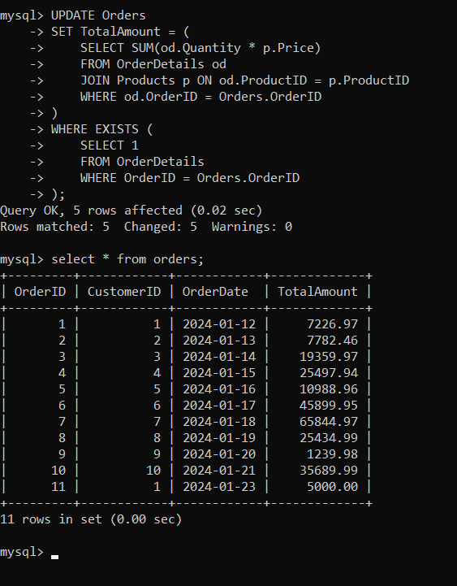

**9. Write an SQL query to delete all orders and their associated order details for a specific customer from the "Orders" and "OrderDetails" tables. Allow users to input the customer ID as a parameter.**

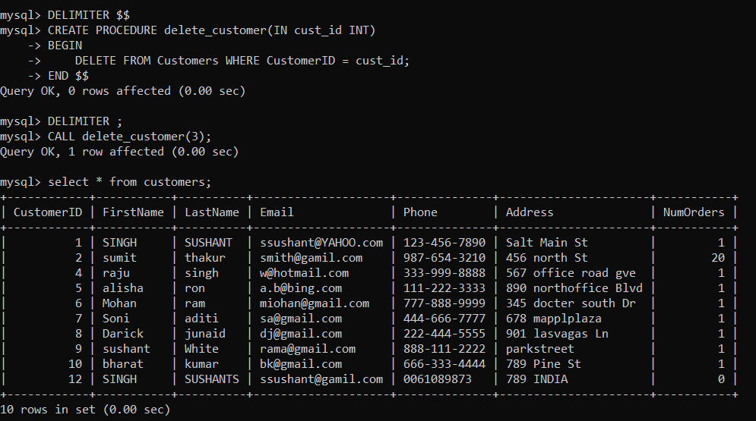

**10. Write an SQL query to insert a new electronic gadget product into the "Products" table, including product name, category, price, and any other relevant details.**

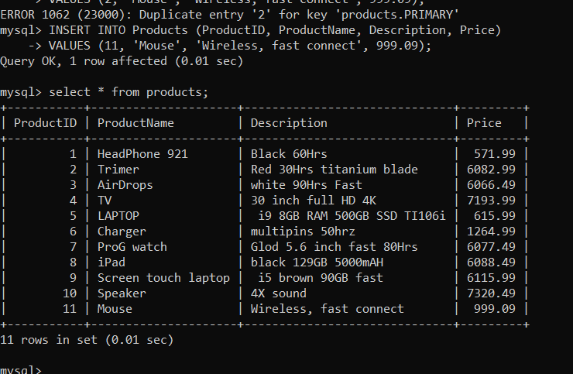

**11. Write an SQL query to update the status of a specific order in the "Orders" table (e.g., from "Pending" to "Shipped"). Allow users to input the order ID and the new status.**

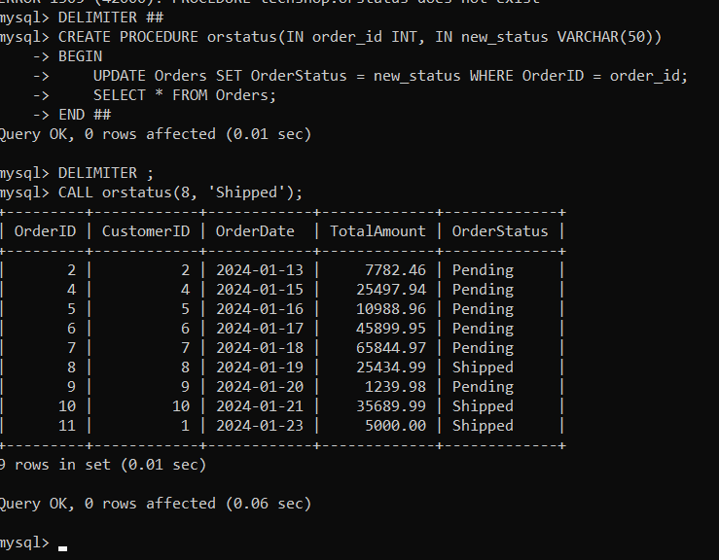

**12. Write an SQL query to calculate and update the number of orders placed by each customer in the "Customers" table based on the data in the "Orders" table.**

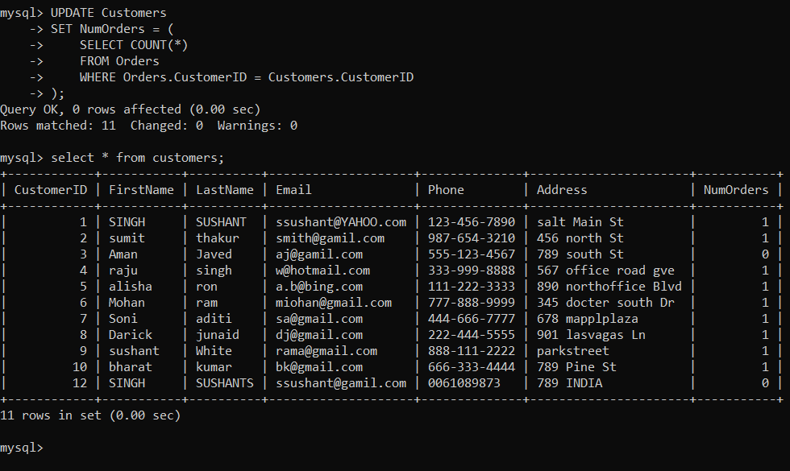

**Task 3. Aggregate functions, Having, Order By, GroupBy and Joins:**

1. 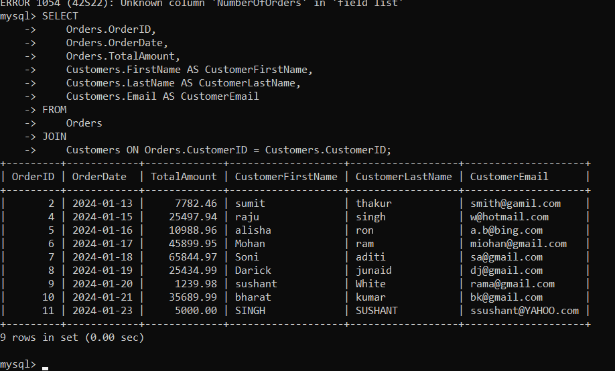**Write an SQL query to retrieve a list of all orders along with customer information (e.g., customer name) for each order.**

**2. Write an SQL query to find the total revenue generated by each electronic gadget product. Include the product name and the total revenue.**

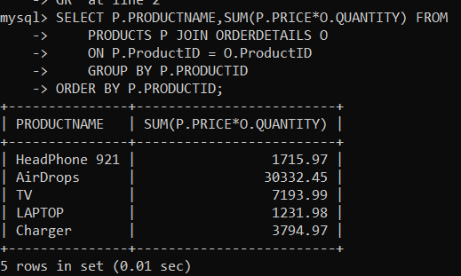

**3) Write an SQL query to list all customers who have made at least one purchase. Include their names and contact information.**

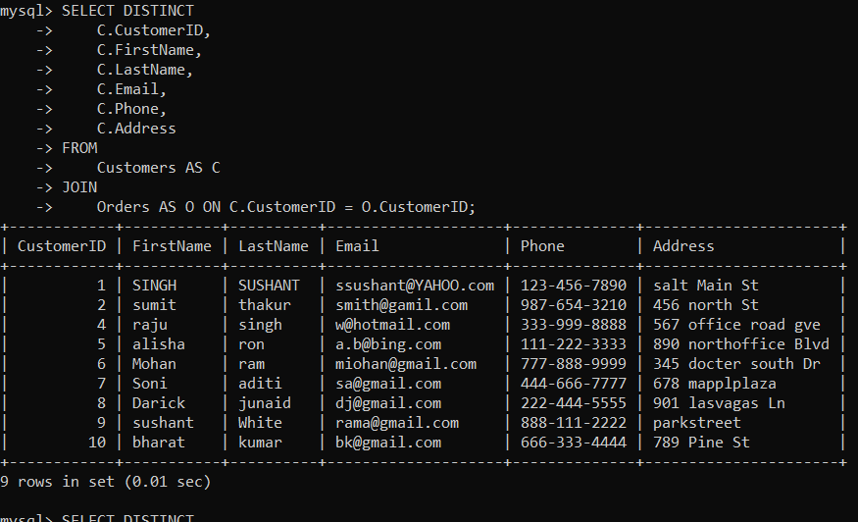

**4) Write an SQL query to find the most popular electronic gadget, which is the one with the highest total quantity ordered. Include the product name and the total quantity ordered.**

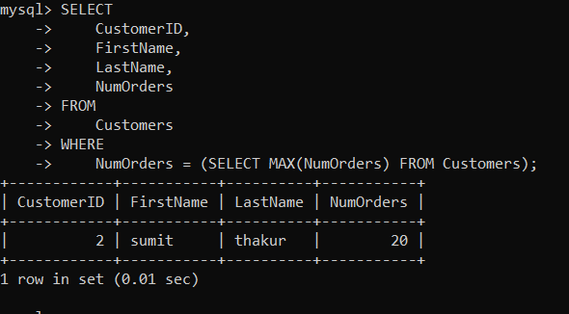

**5) Write an SQL query to retrieve a list of electronic gadgets along with their corresponding categories.**

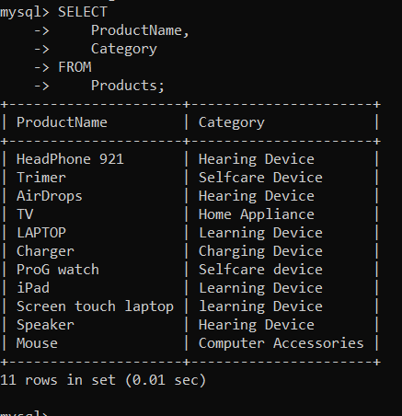

**6. Write an SQL query to calculate the average order value for each customer. Include the customer's name and their average order value.**

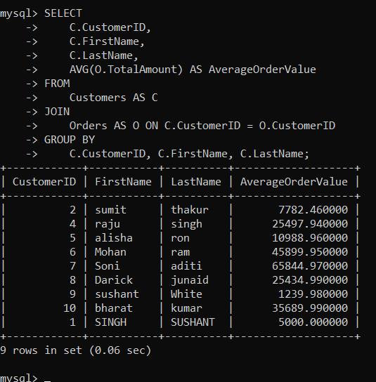

**7) Write an SQL query to find the order with the highest total revenue. Include the order ID, customer information, and the total revenue.**

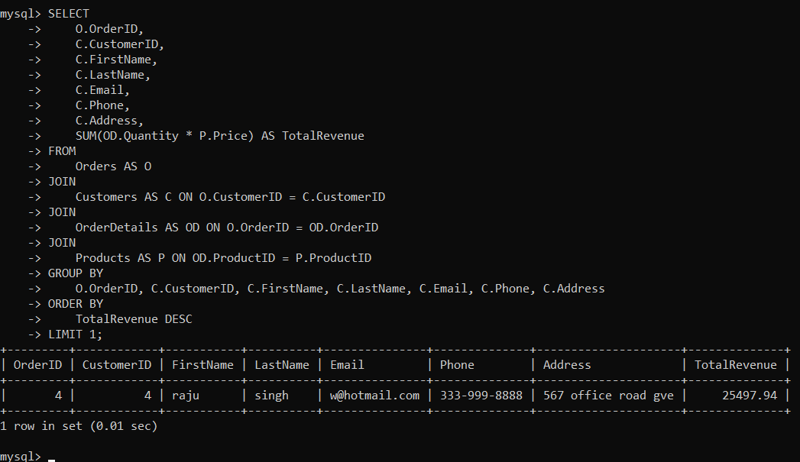

**8. Write an SQL query to list electronic gadgets and the number of times each product has been ordered.**

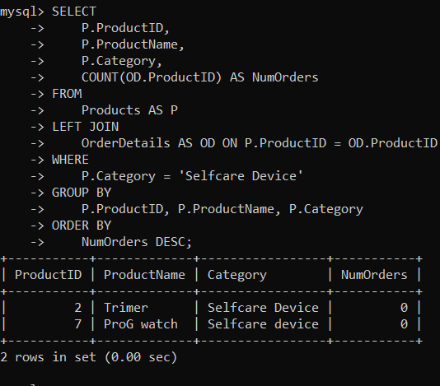

**9. Write an SQL query to find customers who have purchased a specific electronic gadget product. Allow users to input the product name as a parameter**

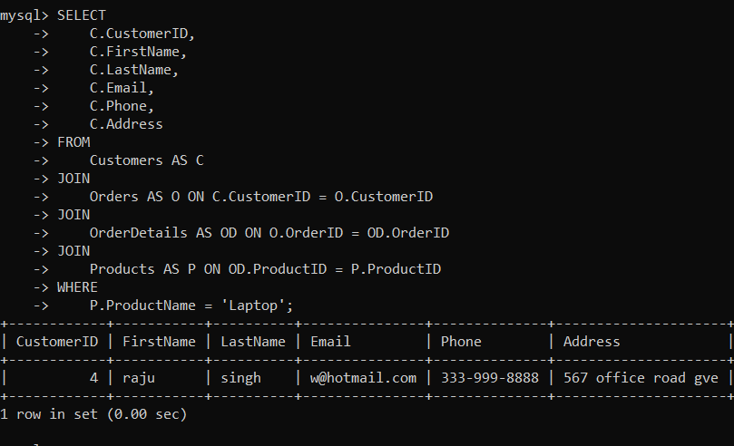

**. 10. Write an SQL query to calculate the total revenue generated by all orders placed within a specific time period. Allow users to input the start and end dates as parameters.**

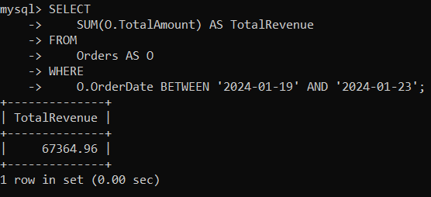

**Task 4. Subquery and its type:**

1. **Write an SQL query to find out which customers have not placed any orders.**

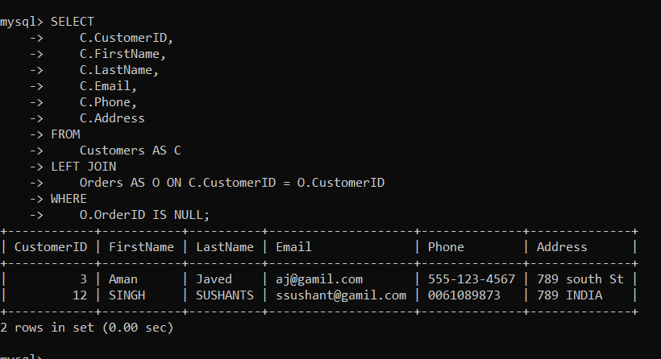

**2. Write an SQL query to find the total number of products available for sale.**

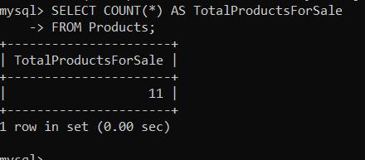

**3. Write an SQL query to calculate the total revenue generated by TechShop**

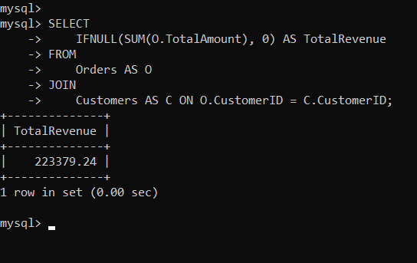

**. 4. Write an SQL query to calculate the average quantity ordered for products in a specific category. Allow users to input the category name as a parameter.**

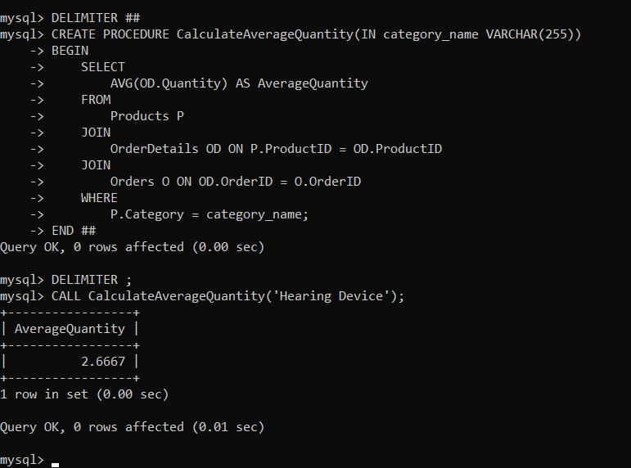

**5. Write an SQL query to calculate the total revenue generated by a specific customer. Allow users to input the customer ID as a parameter.**

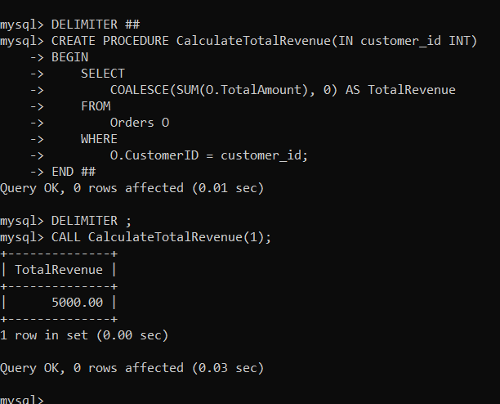

**6. Write an SQL query to find the customers who have placed the most orders. List their names and the number of orders they've placed.**

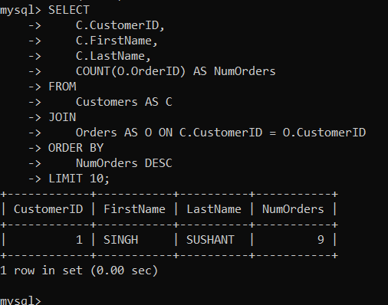

**7. Write an SQL query to find the most popular product category, which is the one with the highest total quantity ordered across all orders.**

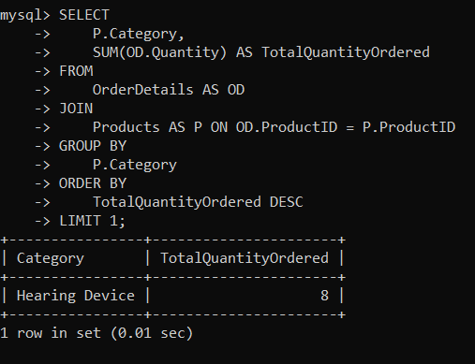

**8. Write an SQL query to find the customer who has spent the most money (highest total revenue) on electronic gadgets. List their name and total spending.**

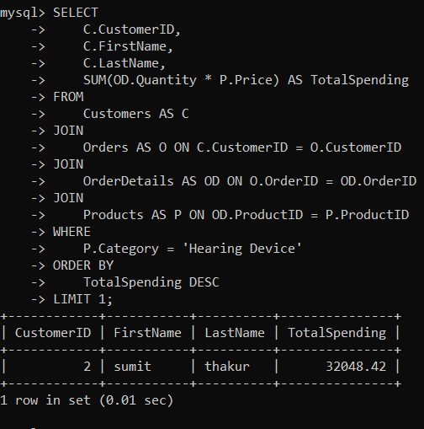

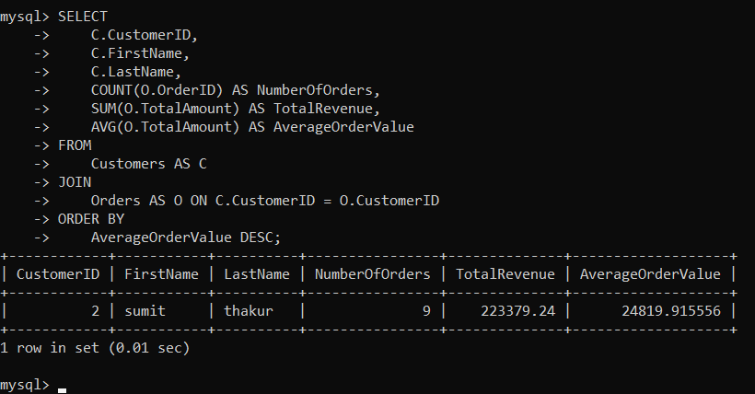**9. Write an SQL query to calculate the average order value (total revenue divided by the number of orders) for all customers.**

**10. Write an SQL query to find the total number of orders placed by each customer and list their names along with the order count.**

